Java Proggram

1. print integer entered by user:

import java.util.Scanner;

class HelloWorld {

public static void main(String[] args) {

Scanner sc=new Scanner(System.in);

System.out.println("enter the integer : ");

int n=sc.nextInt();

System.out.println("the integer is: "+n);

}

}

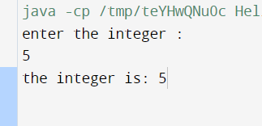

Q no 2:

Usage of primitive data type

import java.util.Scanner;

class HelloWorld {

public static void main(String[] args) {

Scanner sc=new Scanner(System.in);

System.out.println("enter the integer : ");

int n=sc.nextInt();

System.out.println("the integer is: "+n);

System.out.println("enter the float : ");

float m=sc.nextFloat();

System.out.println("the float is: "+m);

System.out.println("enter the boolean : ");

boolean t=sc.nextBoolean();

System.out.println("the bool is: "+t);

}

}

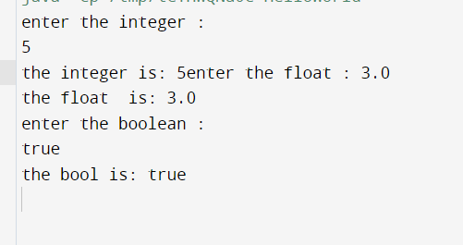

Q no=3

Swapping of two numbers using temp varible

import java.util.Scanner;

class Swapping {

public static void main(String[] args) {

Scanner sc=new Scanner(System.in);

int a=23;

int b=7;

int temp=a;

a= b;

b=temp;

//temp=a;

System.out.println("after swapping");

System.out.println(a);

System.out.println(b);

}

}

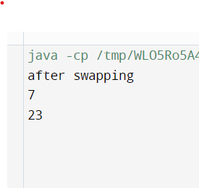

Q no=4

Even or odd

import java.util.Scanner;

class Swapping {

public static void main(String[] args) {

Scanner sc=new Scanner(System.in);

int a;

a=sc.nextInt();

if(a%2==0){

System.out.println("even");

}else{

System.out.println("odd");

}

}

}

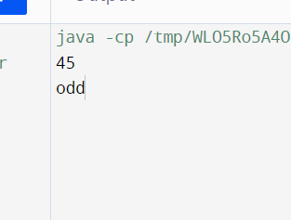

Q no =5

Vowel or consonant

import java.util.Scanner;

class Swapping {

public static void main(String[] args) {

int i=0;

Scanner sc=new Scanner(System.in);

char ch;

ch=sc.next().charAt(0);

if(ch=='a'||ch=='e'||ch=='i'||ch=='o'||ch=='u'||ch=='A'||ch=='E'||ch=='I'||ch=='O'||ch=='U'){

System.out.println("vowel");

}

else{

System.out.println("consonant");

}

}

}

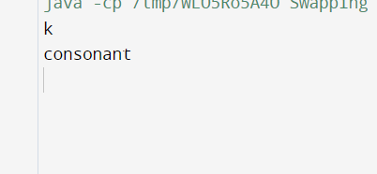

Q no=6

Cheak number is positive or negative

import java.util.Scanner;

class Swapping {

public static void main(String[] args) {

Scanner sc=new Scanner(System.in);

int n;

System.out.println("enter the number : ");

n=sc.nextInt();

if(n>=1){

System.out.println("positive");

}

else{

System.out.println("negative");

}

}

}



Q no=7

Sum of natural number using for loop

import java.util.Scanner;

class Swapping {

public static void main(String[] args) {

Scanner sc=new Scanner(System.in);

int n;

int sum=0;

System.out.println("enter the number : ");

n=sc.nextInt();

for(int i=1;i<=n;i++){

sum+=i;

}

System.out.println(sum);

}

}

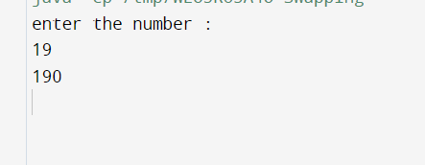

Q no=8

Finf factorial of number using for loop

import java.util.Scanner;

class Swapping {

public static void main(String[] args) {

Scanner sc=new Scanner(System.in);

int n;

int fact=1;

System.out.println("enter the number : ");

n=sc.nextInt();

for(int i=1;i<=n;i++){

fact\*=i;

}

System.out.println(fact);

}

}



Q no =9

Table using for loop

import java.util.Scanner;

class Swapping {

public static void main(String[] args) {

Scanner sc=new Scanner(System.in);

int n;

int ans=1;

System.out.println("enter the number : ");

n=sc.nextInt();

for(int i=1;i<=10;i++){

ans=n\*i;

System.out.println(ans);

}

}

}

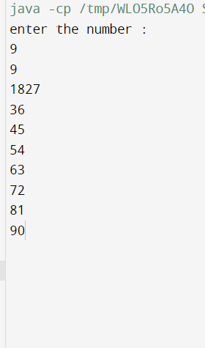

Q no 10

Display uppercased using loop

class HelloWorld {

public static void main(String[] args) {

char ch;

for(ch='A';ch<='Z';ch++){

System.out.print(ch);

}

}

}

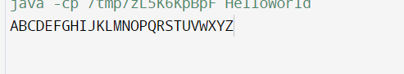

Q no 11

Gcd of two numbers using for loop

import java.util.Scanner;

class Gcd {

public static void main(String[] args) {

Scanner sc=new Scanner(System.in);

int a=sc.nextInt();

int b=sc.nextInt();

int gcd=1;

for(int i=1;i<=a&&i<=b;i++){

if(a%i==0&&b%i==0){

gcd=i;

}

}

System.out.println(gcd);

}

}

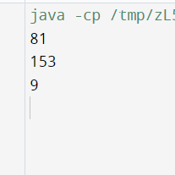

Q no 12

Find reverse of numbers

import java.util.Scanner;

class R{

public static void main(String[] args) {

Scanner sc=new Scanner(System.in);

int a=sc.nextInt();

int rev=0;

for(int i=1;i<=a;i++){

int r=a%10;

rev=rev\*10+r;

a=a/10;

}

System.out.println(rev);

}

}

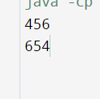

Q no 13

import java.util.Scanner;

class H {

private int a;

public void setA(int a){

this.a=a;

}

public int getA(){

return a;

}

}

class A

{

public static void main(String[] args) {

Scanner sc=new Scanner(System.in);

System.out.println("enter a number: ");

int a;

a=sc.nextInt();

H q=new H();

q.setA(a);

System.out.println("the entered number is:"+q.getA());

}

}

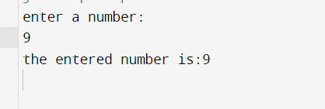

Q no 18

Demonstrate the use of Scanner class for taking input and output from usr

import java.util.Scanner;

public class A{

public static void main(String args[]){

System.out.println("Enter any number: ");

Scanner sc=new Scanner(System.in);

int n=sc.nextInt();

System.out.println(n);

}

}

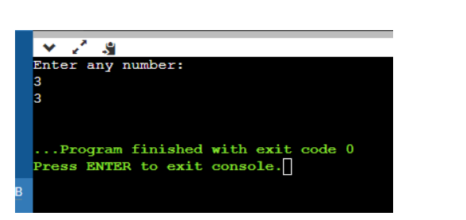

Q no 19

Light program

import java.util.Scanner;

public class Light{

boolean isOn;

void switchOn(){

isOn=true;

System.out.println(isOn);

}

void switchOff(){

isOn=false;

System.out.println(isOn);

}

public static void main(String args[])

{ Light led=new Light();

Light halogen=new Light();

led.switchOn();

halogen.switchOff();

System.out.println(led.isOn);

}

}

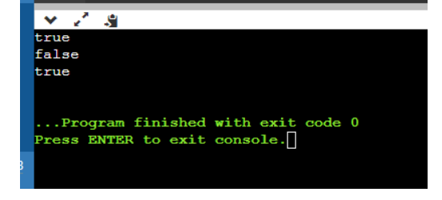

20. Box Prog

public class Box

{

private int height;

private int length;

private int breadth;

Box(){ height=0;

length=0;

breadth=0;

}

Box(int height, int length, int breadth){

this.height=height; this.length=length; this.breadth=breadth; }

public int Volume(){

return(length\*breadth\*height); }

public static void main(String args[]){ Box cuboid1=new Box(); System.out.println("The area of the cuboid is" + cuboid1.Volume());

Box cuboid2=new Box(10,15,30);

System.out.println("The area of cuboid is"+ cuboid2.Volume)

}

}

